GENETICS AND EVOLUTION TEST.

DO NOT MARK THIS PAPER!

1. In biological terms, what is a species? A group of organisms that
a) are similar in form and structure.
b) can interbreed.
c) share common features.
d) live in the same habitat.

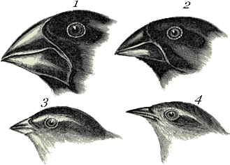

2. The picture of the above finches is used to illustrate:
a) phylogeny of finches.
b) change over time.
c) specialization of beaks for different diets
d) natural selection.

3. Most human body cells contain

a) 46 pairs of chromosomes.
b) 46 individual chromosomes.
c) 23 individual chromosomes.
d) 23 pairs of matching chromosomes.

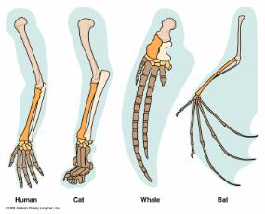

4. The image above illustrates:
a) vestigial structures.
b) homologous structures.
c) the fossil record.
d) natural selection.

5. Which of the following is an example of artificial selection?

a) A panda's thumb.
b) The breeding of dogs.
c) The Galapagos finches.
d) A giraffe's neck.

6. According to the theory of evolution by natural selection, which of the following is true?
a) Random mating is necessary for evolution to occur.
b) Variation does not exist between members of the same species.
c) Populations will change to better fit their environment
d) Individuals will adapt to their environment.

7. Which of the following are assumptions made with regards to the Theory of Evolution by Natural selection?
a) Organisms compete with each other to survive.
b) Variations exist among organisms.
c) Not all organisms that are born survive to reproduce.
d) All of these.

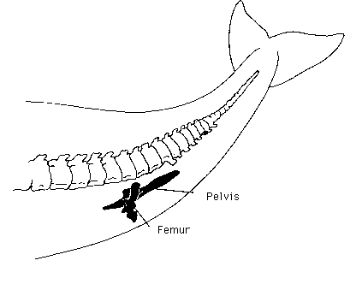

8. The image illustrates which of the following?
a) Artificial selection.
b) Acquired characteristics.
c) Homologous structures.
d) Vestigial structures.

9. Genetic engineering is a process in which scientists are able to
- selectively breed desirable characteristics in organisms from generation to generation.
- control the rate of mutations in organisms.
- cross-breed one species of organism with another.
- insert genes from one kind of organism into another.

10. Which of the following outcomes would you predict for a population of bacteria exposed to a new antibiotic?

Over many generations, bacteria would become resistant to the antibiotic.

Over a few generations, the bacteria would evolve into archaebacteria.

Over a few generations, the bacteria would become extinct.

Over many generations, the bacteria would become more likely to be affected by the antibiotic.

11. Which of the following is an example of convergent evolution?

Whales and sharks have similar body designs.

Bees and hummingbirds have similar body designs.

Bats and birds have similar body designs.

All of these.

12. Dominant characteristics are so named because they

are pure breeding.

mask the effects of an alternative allele that is also present.

are more desirable than recessive alleles.

occur more often than recessive alleles.

13. In humans the sex chromosomes

are a matching pair only in the female.

are a matching pair only in the male.

include an X and a Y chromosome.

include two X chromosomes in males.

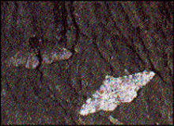

14. The image above illustrates how peppered moths

a) are related to other moths.
b) adapted to a changing environment.
c) became extinct.
d) became two species.

15. Wombats and koalas are separate but related species of Australian
marsupial. They represent an example of

a) divergent evolution.
b) convergent evolution.
c) parallel evolution.
d) none of the above.

16. The study of genetics is

a) the study of interbreeding of animals.
b) examination of the methods of reproduction in plants and animals.
c) the study of hereditary trends.
d) examination of genes in the cells of plants and animals.

17. Cri du Chat Syndrome is a disorder which results in low set ears, mental
retardation, voice damage and other special symptoms. Sufferers of this
disorder are seen to have cells with a small portion missing from one
particular chromosome. The obvious deduction is that

a) during mitosis one of the chromosomes has shrunk.
b) the part of the chromosome which was lost contained genes dealing with
mental ability, voice and ear position.
c) the missing part was lost due to radiation.
d) the child would not be expected to live for more than 15 years.

18. When white Japanese ‘Four o’clock’ flowers are crossed with red ones,
the offspring are all pink. This type of inheritance is known as

a) co dominance.
b) incomplete dominance.
c) dominant pink.
d) recessive red and white.

19 Which of the following features of a human is NOT influenced by the
environment?

a) Height.
b) Weight.
c) Skin colour.
d) Blood group.

20. Variation within a species refers to

a) different traits exhibited by the members of a species.
b) changes that occur to the gene structure.
c) the variety of family groups within that species.
d) natural selection processes which occur within animal and plant
communities.

Part B. Written. Show ALL of the working out on the lined paper provided where appropriate.

1. Write down the letters that are next to the statements below.
Choose the terms that match them from the box and write them alongside.

A Chemical substance that makes up chromosomes.

B An organism that has two identical alleles for a particular characteristic.

C Strand of genetic material found in the nucleus of a cell.

D Chemical units that pair up to make DNA.

E The type of genes that an organism has with respect to particular
characteristics.

heterozygous homozygous DNA chromosome bases genes phenotype genotype cytoplasm

(5 marks)

2. Look at the pedigree below.

Using the letters R and r, write down the genes that individuals K, L and M must have. ON THE LINED PAPER.
(3 marks)

3. Two tall hybrid plants are crossed. Using the letters ‘T’ for tall and
‘t’ for short, work out the genotypes and phenotypes of their offspring.

(3 marks)

4. In guinea pigs, a rough coat is dominant to a smooth coat. If the offspring
ended up so that half of them had a rough coat and half of them had a
smooth coat, what must the genotypes of the parents be?

(3 marks)

5. A black feathered chicken is crossed with a white feathered chicken and all
of their offspring in the F1 generation have blue/grey feathers.

a) What is the pattern of inheritance? (1mark)

b) Show how this pattern of inheritance occurs in this case. (3 marks)

c) Two of the F1 generation are crossed. What are the genotypes and
phenotypes of their offspring?

(3 marks)

6. A woman who is heterozygous for colour blindness has children with a
colour blind man. What is the probability of them having a colour blind son?

(4 marks)

